Test Case: tc005_SPX_Dev5_Crear_Requisicion_Spot_Con_FAD_Tipo_Cobro_Project
Step 1 - Enter username and password and click to button Enter: Credentials Entered
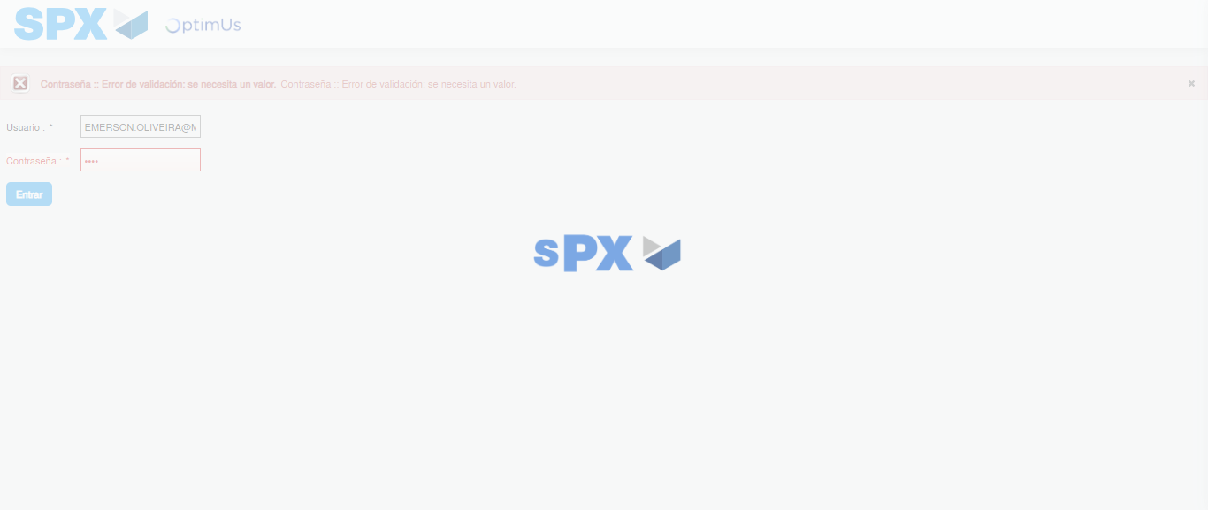Image file-name: QC_Testing-tc005_SPX_Dev5_Crear_Requisicion_Spot_Con_FAD_Tipo_Cobro_Project-1785975099850

Step 2 - Select to UEN and Access to Spot Buy Requisitions : UEN Correctly selected and Correct access
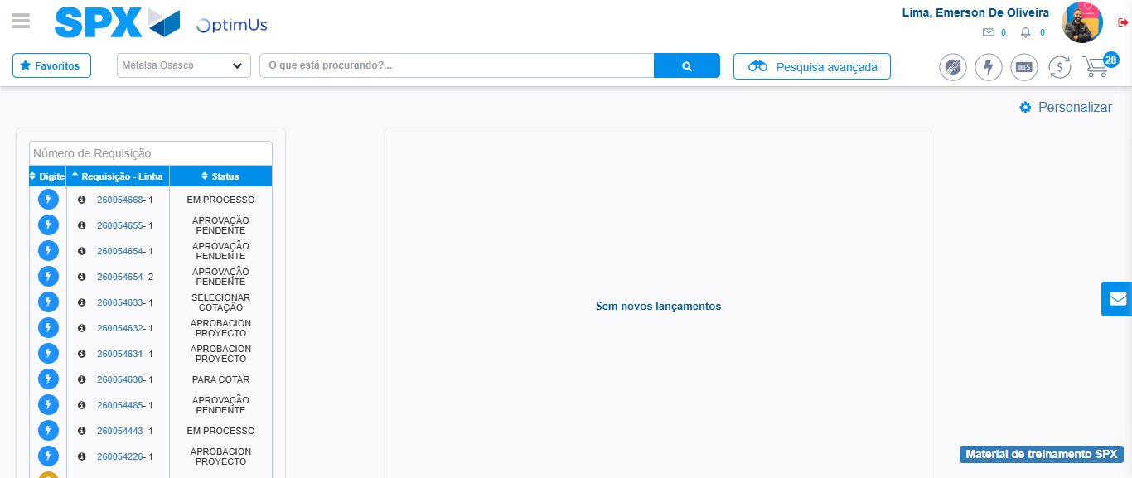Image file-name: QC_Testing-tc005_SPX_Dev5_Crear_Requisicion_Spot_Con_FAD_Tipo_Cobro_Project-1785975125267

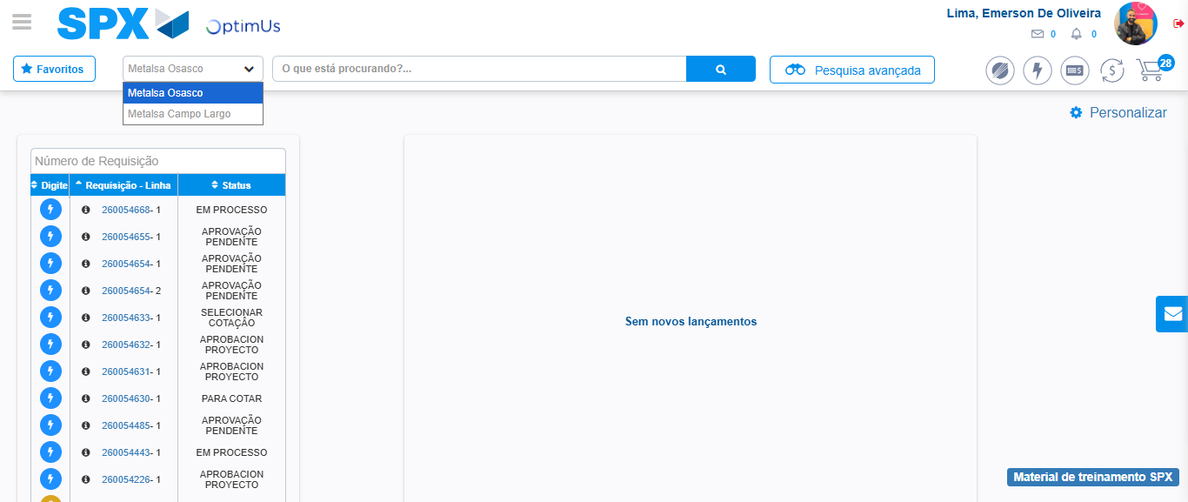Image file-name: QC_Testing-tc005_SPX_Dev5_Crear_Requisicion_Spot_Con_FAD_Tipo_Cobro_Project-1785975127736

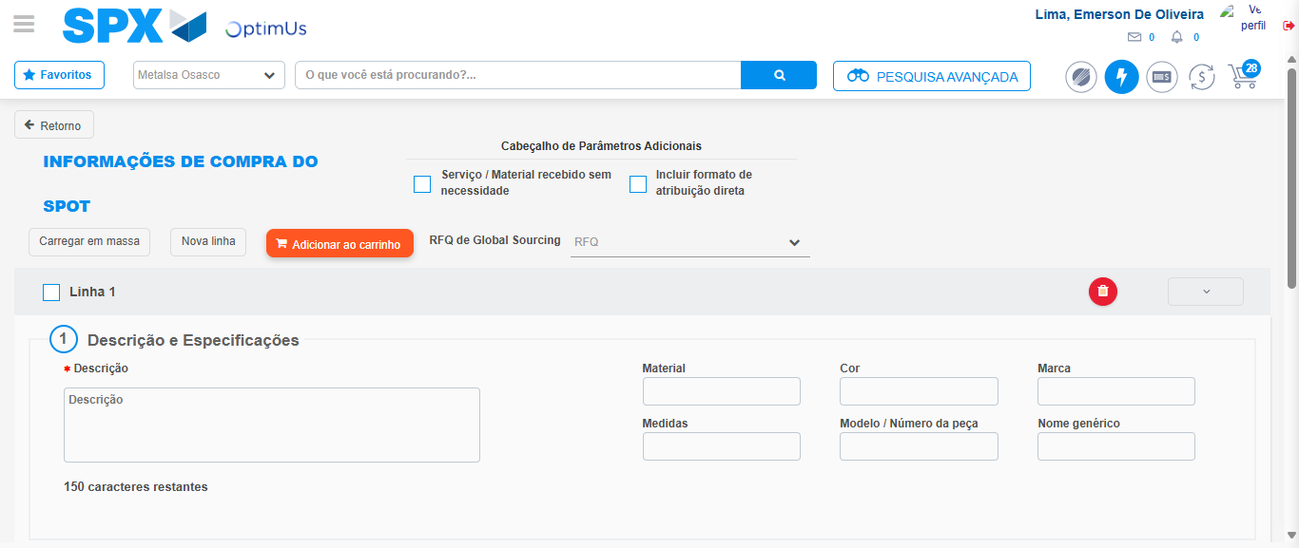Image file-name: QC_Testing-tc005_SPX_Dev5_Crear_Requisicion_Spot_Con_FAD_Tipo_Cobro_Project-1785975136195

Step 3 - Add FAD to Requisition: FAD Successfully Added
Image file-name: QC_Testing-tc005_SPX_Dev5_Crear_Requisicion_Spot_Con_FAD_Tipo_Cobro_Project-1785975136451

Image file-name: QC_Testing-tc005_SPX_Dev5_Crear_Requisicion_Spot_Con_FAD_Tipo_Cobro_Project-1785975136638

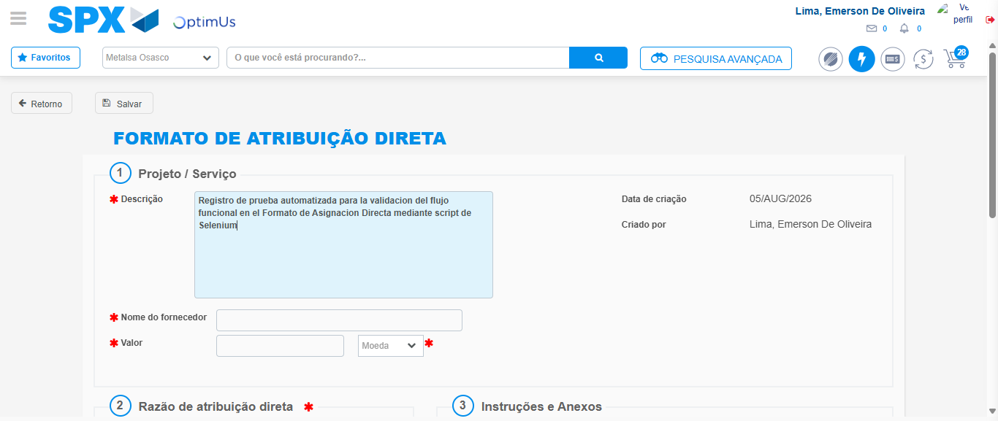Image file-name: QC_Testing-tc005_SPX_Dev5_Crear_Requisicion_Spot_Con_FAD_Tipo_Cobro_Project-1785975139491

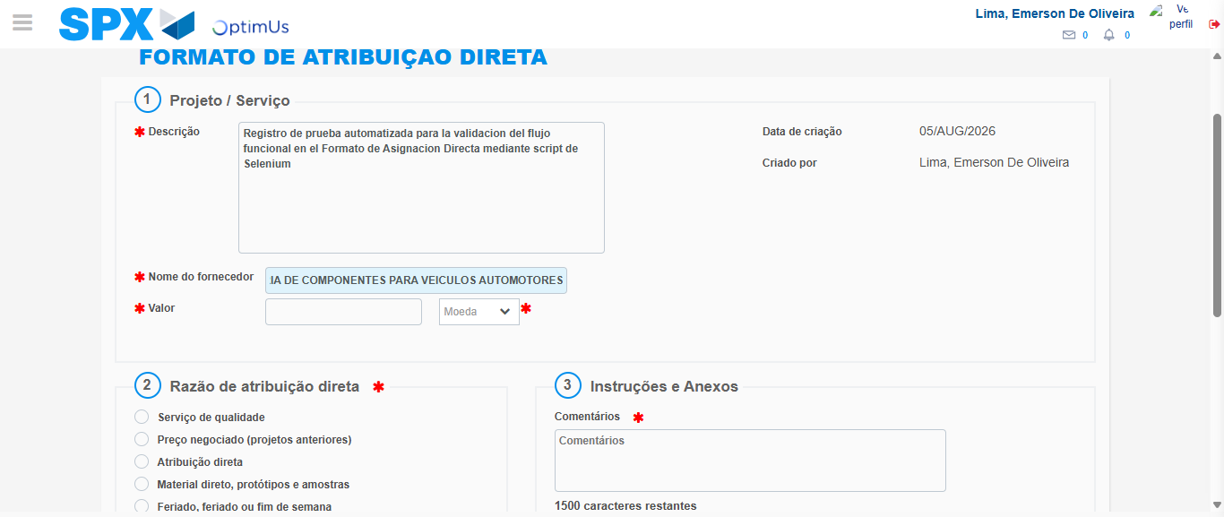Image file-name: QC_Testing-tc005_SPX_Dev5_Crear_Requisicion_Spot_Con_FAD_Tipo_Cobro_Project-1785975148674

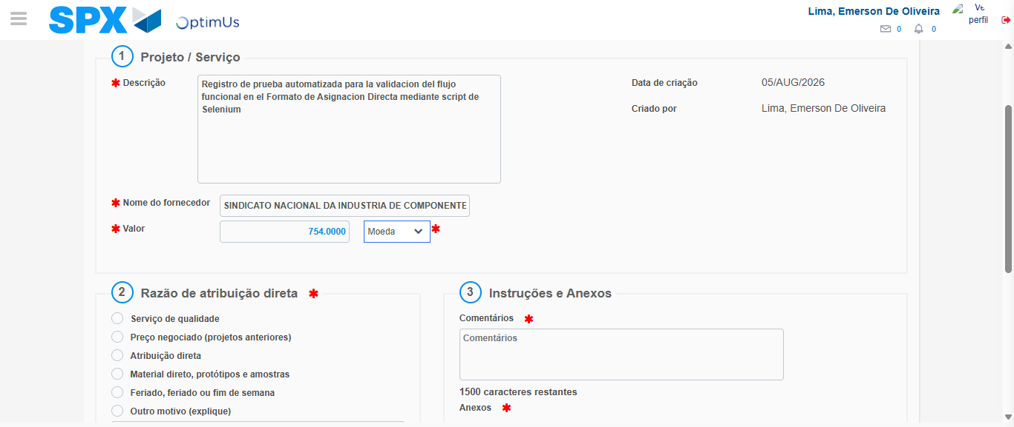Image file-name: QC_Testing-tc005_SPX_Dev5_Crear_Requisicion_Spot_Con_FAD_Tipo_Cobro_Project-1785975149055

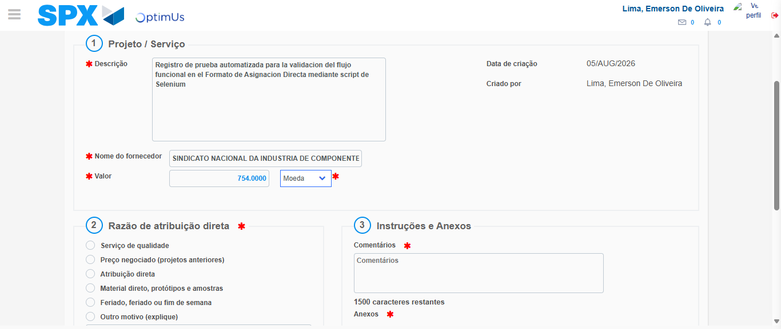Image file-name: QC_Testing-tc005_SPX_Dev5_Crear_Requisicion_Spot_Con_FAD_Tipo_Cobro_Project-1785975149249

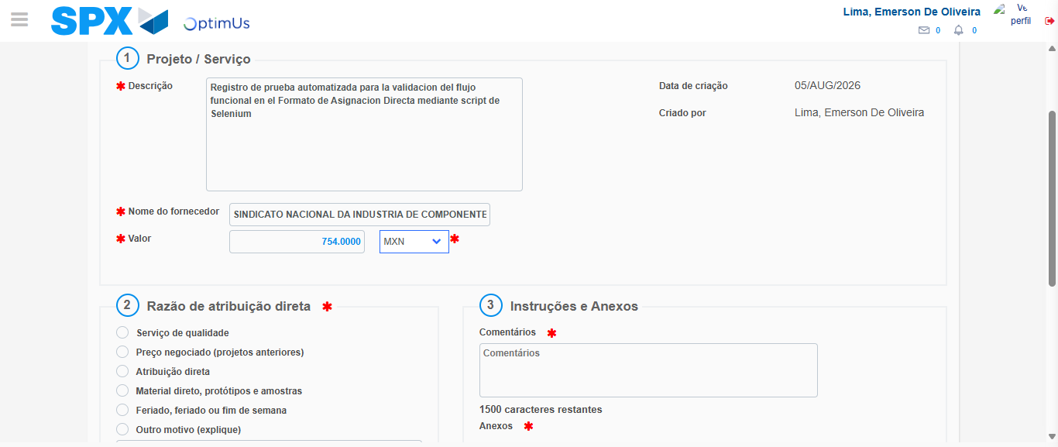Image file-name: QC_Testing-tc005_SPX_Dev5_Crear_Requisicion_Spot_Con_FAD_Tipo_Cobro_Project-1785975149590

Image file-name: QC_Testing-tc005_SPX_Dev5_Crear_Requisicion_Spot_Con_FAD_Tipo_Cobro_Project-1785975149778

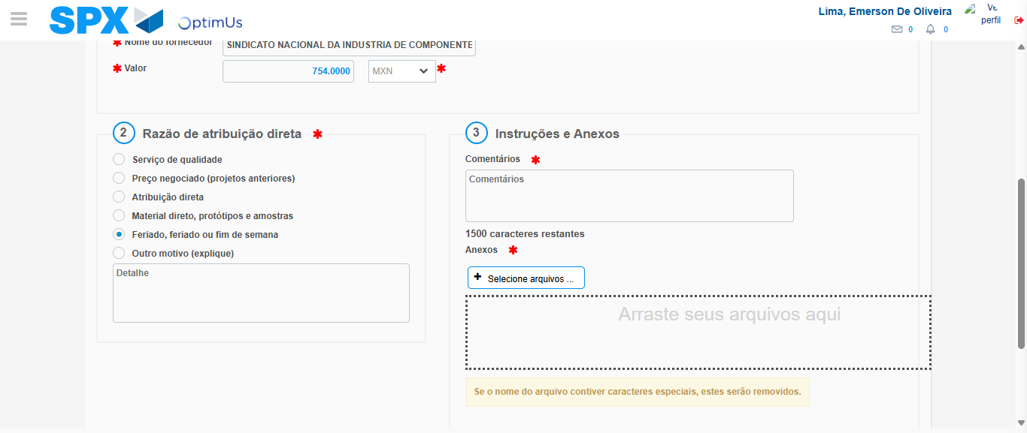Image file-name: QC_Testing-tc005_SPX_Dev5_Crear_Requisicion_Spot_Con_FAD_Tipo_Cobro_Project-1785975150638

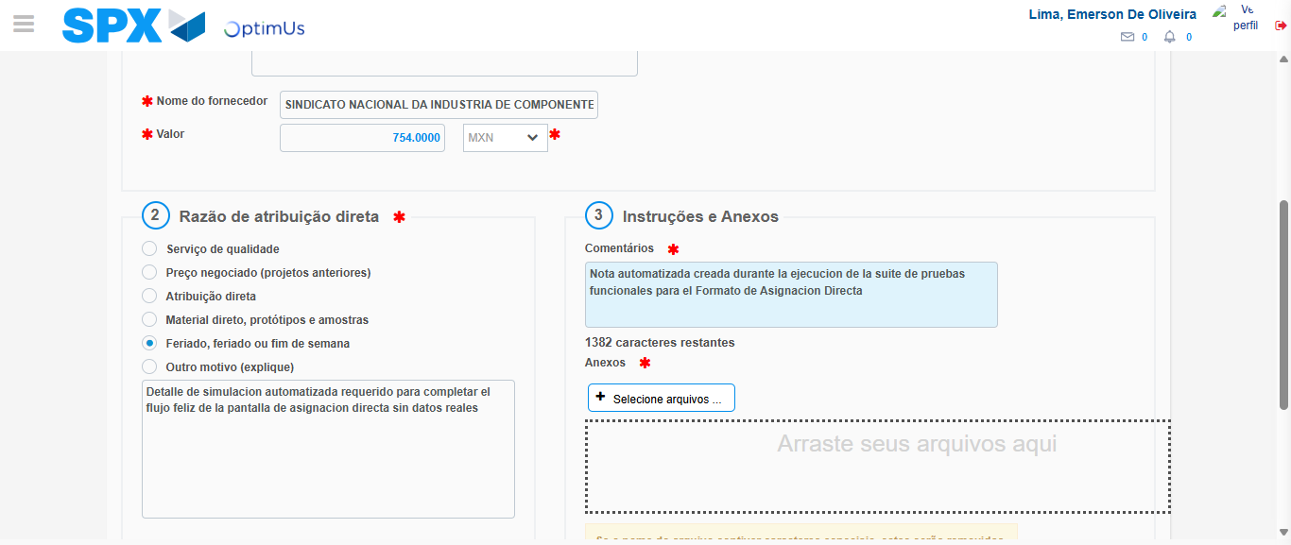Image file-name: QC_Testing-tc005_SPX_Dev5_Crear_Requisicion_Spot_Con_FAD_Tipo_Cobro_Project-1785975161625

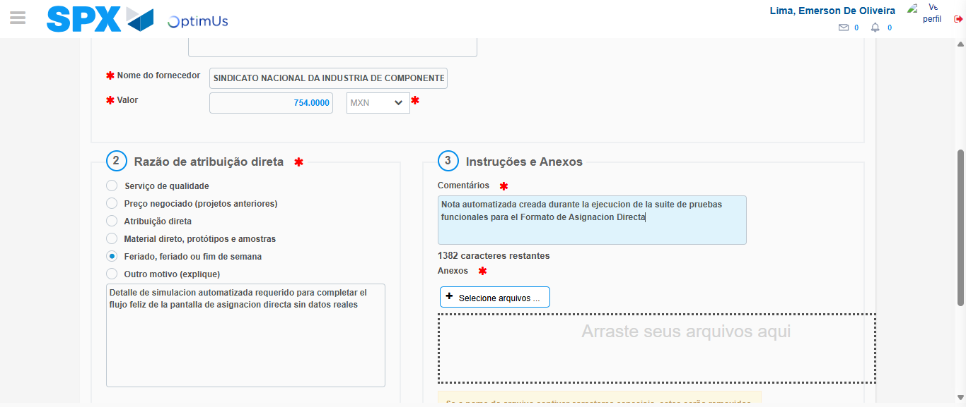Image file-name: QC_Testing-tc005_SPX_Dev5_Crear_Requisicion_Spot_Con_FAD_Tipo_Cobro_Project-1785975162276

Step 4 - Data Capture Spot Buy Requisition: Data captured correctly
Image file-name: QC_Testing-tc005_SPX_Dev5_Crear_Requisicion_Spot_Con_FAD_Tipo_Cobro_Project-1785975136451

Image file-name: QC_Testing-tc005_SPX_Dev5_Crear_Requisicion_Spot_Con_FAD_Tipo_Cobro_Project-1785975136638

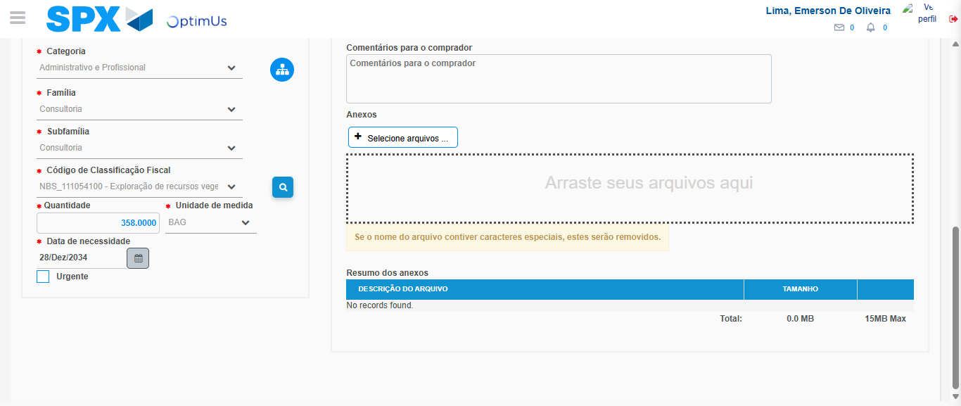Image file-name: QC_Testing-tc005_SPX_Dev5_Crear_Requisicion_Spot_Con_FAD_Tipo_Cobro_Project-1785975179266

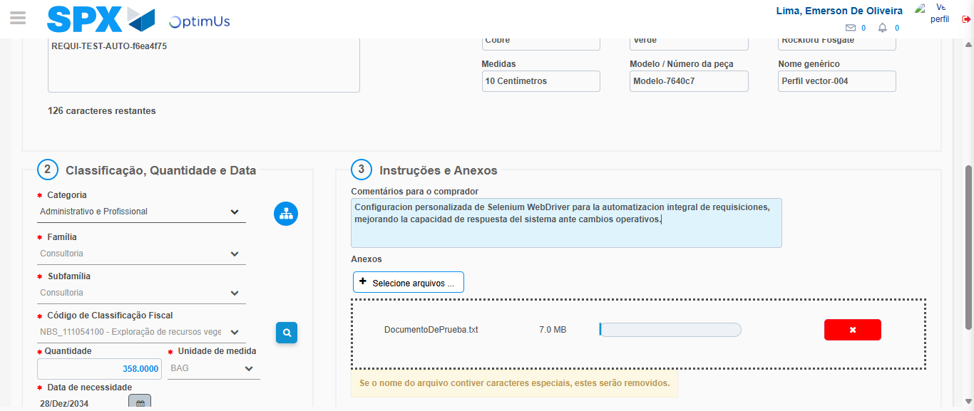Image file-name: QC_Testing-tc005_SPX_Dev5_Crear_Requisicion_Spot_Con_FAD_Tipo_Cobro_Project-1785975180075

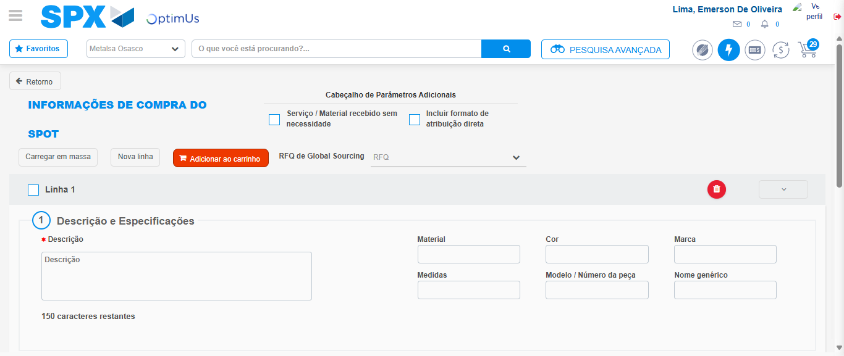Image file-name: QC_Testing-tc005_SPX_Dev5_Crear_Requisicion_Spot_Con_FAD_Tipo_Cobro_Project-1785975190476

Step 8 - Return to Main Page SPX : Return to Main Page SPX
Image file-name: QC_Testing-tc005_SPX_Dev5_Crear_Requisicion_Spot_Con_FAD_Tipo_Cobro_Project-1785975125267

Image file-name: QC_Testing-tc005_SPX_Dev5_Crear_Requisicion_Spot_Con_FAD_Tipo_Cobro_Project-1785975127736

Image file-name: QC_Testing-tc005_SPX_Dev5_Crear_Requisicion_Spot_Con_FAD_Tipo_Cobro_Project-1785975136195

Image file-name: QC_Testing-tc005_SPX_Dev5_Crear_Requisicion_Spot_Con_FAD_Tipo_Cobro_Project-1785975192657

Image file-name: QC_Testing-tc005_SPX_Dev5_Crear_Requisicion_Spot_Con_FAD_Tipo_Cobro_Project-1785975192824

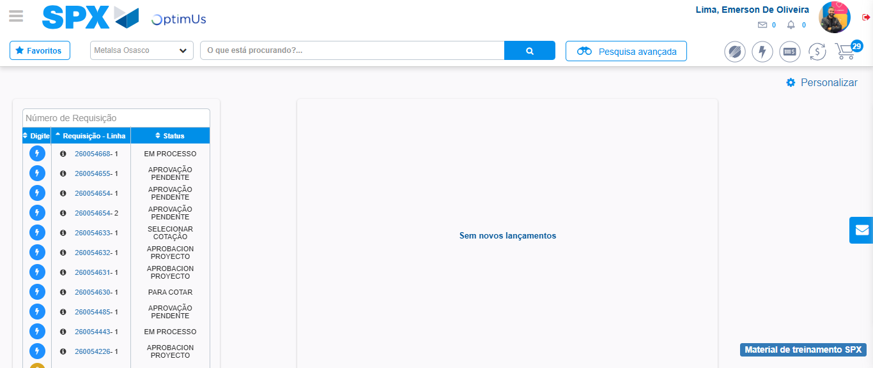Image file-name: QC_Testing-tc005_SPX_Dev5_Crear_Requisicion_Spot_Con_FAD_Tipo_Cobro_Project-1785975213823

Step 9 - Log Out : Log Out SPX
Image file-name: QC_Testing-tc005_SPX_Dev5_Crear_Requisicion_Spot_Con_FAD_Tipo_Cobro_Project-1785975213993

